Andrew Owen

10/11/19

MATH 341

Homework 5

1. Take $x∈F$  
   If $FE= ∅, x∈E^{c} which x∈FE^{c}$ 
   If $FE≠ ∅, x∈E or ∈E^{c} such that x∈FE or x∈FE^{c}$  
   So, $F⊆FE∪FE^{c}$  
     
   Take $x∈FE∪FE^{c}$ $x∈FE or x∈FE^{c}, so x∈F and x∈E or x∈F and x∈E^{c}$ $x∈F$ $So, FE∪FE^{c}⊆F$ $F=FE∪FE^{c}$
2. A) (total - In Language)/total = $\frac{100-50}{100}= .5=50\%$  
     
   B) $\frac{14+10+8}{100}=\frac{32}{100}= .32=32\%$  
     
   C) ${((}_{ 2}^{50})+(_{ 1}^{50})(_{ 1}^{50}))/(_{ 2}^{100})$ = $0.7525$ = 75.225%
3. ✓
4. Freshman - 10 $P(E_{2})=(_{15}^{85})/(_{15}^{110})= 0.015$ 
    Sophomore - 25 $P\left(E_{3}\right)=(_{15}^{80})/(_{15}^{110})= 0.0056$ 
    Junior - 30 $P\left(E_{4}\right)=(_{15}^{65})/(_{15}^{110})= 0.00018$ 
    Senior - 45 $P\left(E_{1}E_{2}\right)= (_{15}^{75})/(_{15}^{110})= 0.001939$ $P\left(E_{1}E_{3}\right)= (_{15}^{70})/(_{15}^{110})= 0.000614$ $P\left(E_{1}E_{4}\right)= (_{15}^{55})/(_{15}^{110})= 0.00001012$ $P\left(E_{2}E_{3}\right)= (_{15}^{55})/(_{15}^{110})= 0.00001012$ $P\left(E_{2}E_{4}\right)=(_{15}^{40})/(_{15}^{110})= 0.00000003$ $P\left(E_{3}E_{4}\right)=(_{15}^{35})/(_{15}^{110})= 2.762*{10}^{-9}$ $P\left(E_{1}E_{2}E_{3}\right)= (_{15}^{45})/(_{15}^{110})= 0.00000029$ $P\left(E_{1}E_{2}E_{4}\right)= (_{15}^{30})/(_{15}^{110})= 1.3193*{10}^{-10}$ $P\left(E_{1}E_{3}E_{4}\right)= (_{15}^{25}$
      
      
      
      
      
      
      
      
    ) $/(_{15}^{110})= 2.78*{10}^{-12}$ $P\left(E_{2}E_{3}E_{4}\right)=(_{15}^{10})/(_{15}^{110})= 0$ $P\left(E_{1}E_{2}E_{3}E_{4}\right)=(_{15}^{0})/(_{15}^{110})= 0$ ${P(E}_{1})+ P\left(E_{2}\right)+ P\left(E_{3}\right)+ P\left(E_{4}\right)- P\left(E_{1}E_{2}\right)- P\left(E_{1}E_{3}\right)- P\left(E_{1}E_{4}\right)- P\left(E_{2}E_{3}\right)- P\left(E_{2}E_{4}\right)- P\left(E_{3}E_{4}\right)+$ $P\left(E_{1}E_{2}E_{3}\right)+ P\left(E_{1}E_{2}E_{4}\right)+ P\left(E_{1}E_{3}E_{4}\right)+ P\left(E_{2}E_{3}E_{4}\right)- P\left(E_{1}E_{2}E_{3}E_{4}\right)$
      
      
     
      
     
   = 0.2382 = 23.82%
5. If $P\left(\bigcup_{i=1}^{∞}{E_{i}}\right)≤\sum_{i=1}^{∞}{P(E_{i})}$, one case must be that all events are mutually exclusive (noted with a ‘\*’). Meaning $\bigcup_{i=1}^{∞}{E_{i}^{*}= \sum_{i=1}^{∞}{{P(E}_{i}^{*}) }as \bigcap_{i=1}^{∞}{E_{i}^{*}= ∅}}$. If one or more of the cases are not mutually exclusive, then $\bigcap_{i=1}^{∞}{E_{i}≠∅} so \bigcup_{i=1}^{∞}{E_{i}< {\sum_{i=1}^{∞}{E}}_{i}}$ as to not over-count the intersection between two or more events. So, $P\left(\bigcup_{i=1}^{∞}{E_{i}}\right)≤\sum_{i=1}^{∞}{P(E_{i})}$ as it accounts for all cases of possible intersection between the events.

(Histogram for part A below)

1. The likelihood of Baltimore winning 10 games in a row in one season is relatively low, sitting at approximately 0.025 or 2.5% (from the data). While the likelihood of them winning 15 games in a row is even lower (low enough that I cannot visually estimate its value). So while winning ten games in a row is unlikely, it is far more unlikely that they will win 1 games in a row.
2. When I simulated 10000 seasons, there were 31 seasons where Cleveland Indians got a 22 or higher game win streak. 31/10000 = 0.0031 = 0.31%, which is a very unlikely possibility that they will win 22 or more games in a row.
3. When I simulated 10000 seasons, there were 12 seasons where the Los Angeles Dodgers lost 11 or more games in a row. 12/10000 = 0.0012 = 0.12%, which is a very unlikely possibility that they will lose 11 or more games in a row.

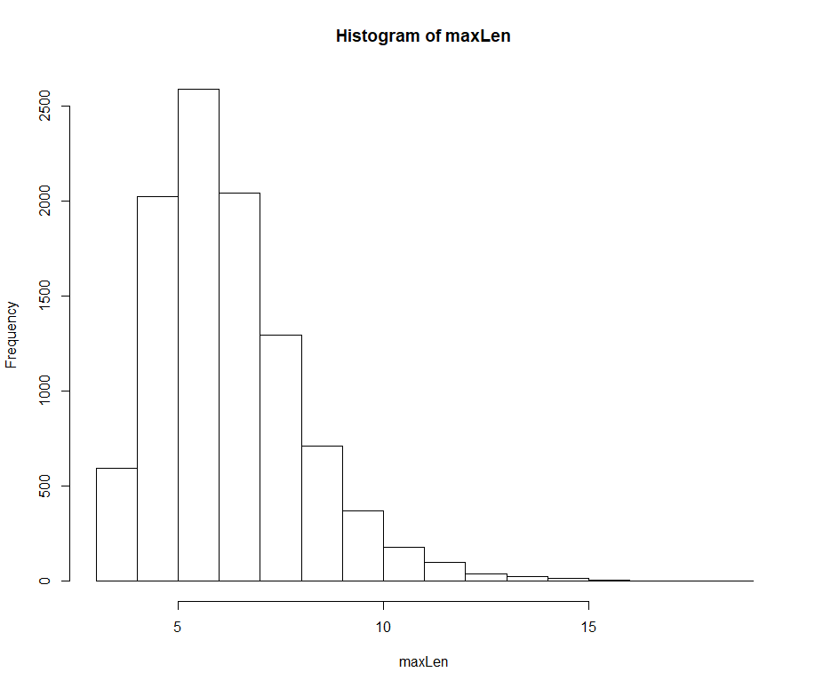

1. A) $P\left(A | B\right)=1-\frac{P\left(A∩B\right)}{P\left(A\right)}=1-\frac{.27}{.79}= 1-0.34=0.66=66\%$  
   B) $P\left(B | A\right)=\frac{P\left(A∩B\right)}{P\left(A\right)}=\frac{.27}{.38}=0.7105=71.05\%$